Turtles of South Carolina

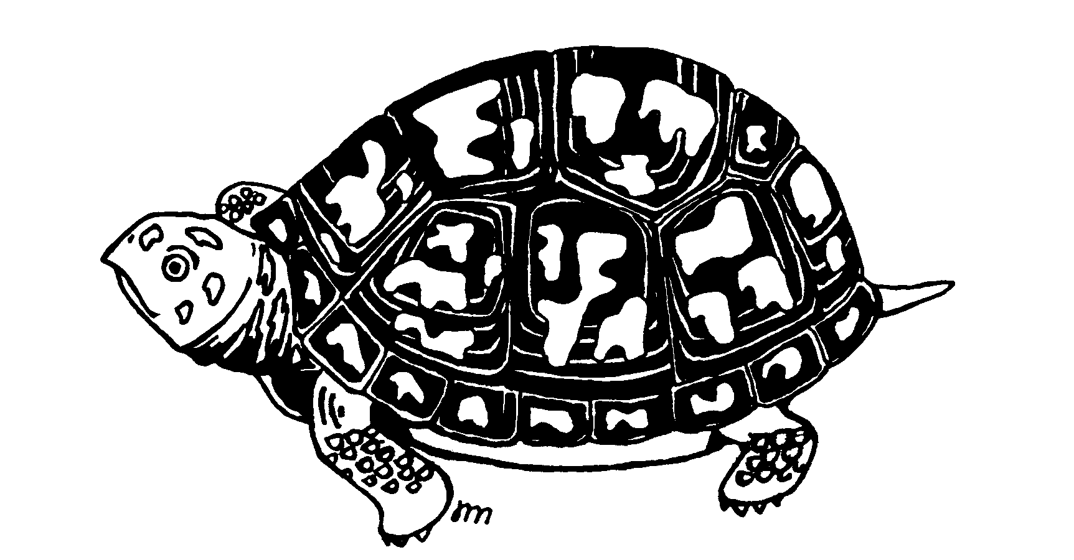

COMMON NAME TAXONOMIC NAME

LAND TURTLES

EASTERN BOX TURTLE TERRAPENE CAROLINA CAROLINA

GOPHER TORTOISE GOPHERUS POLYPHEMUS

AQUATIC TURTLES

BOG TURTLE GLYPTEMYS MUHLENBERGI
EASTERN CHICKEN TURTLE DEIROCHELYS RETICULARIA RETICULARIA
COMMON SNAPPING TURTLE CHELYDRA SERPENTINA SERPENTINA
DIAMONDBACK TERRAPIN MALACLEMYS TERRAPIN CENTRATA
EASTERN MUD TURTLE KINOSTERNON SUBRUBRUM SUBRUBRUM
FLORIDA MUD TURTLE KINOSTERNON BAURII
COMMON MUSK TURTLE (STINKPOT) STERNOTHERUS ODORATUS
EASTERN PAINTED TURTLE CHRYSEMYS PICTA PICTA
GULF COAST SPINY SOFTSHELL TURTLE TRIONYX SPINIFER ASPER
FLORIDA SOFTSHELL TURTLE TRIONYX FEROX
EASTERN RIVER COOTER PSEUDEMYS CONCINNA CONCINNA
FLORIDA COOTER PSEUDEMYS FLORIDANA FLORIDANA
SPOTTED TURTLE CLEMMYS GUTTATA
YELLOW-BELLIED TURTLE TRACHEMYS SCRIPTA SCRIPTA

MARINE
LOGGERHEAD TURTLE (State Turtle) CARETTA CARETTA
KEMPS RIDLEY LEPIDOCHELYS KEMPI
GREEN TURTLE CHELONIA MYDAS MYDAS

