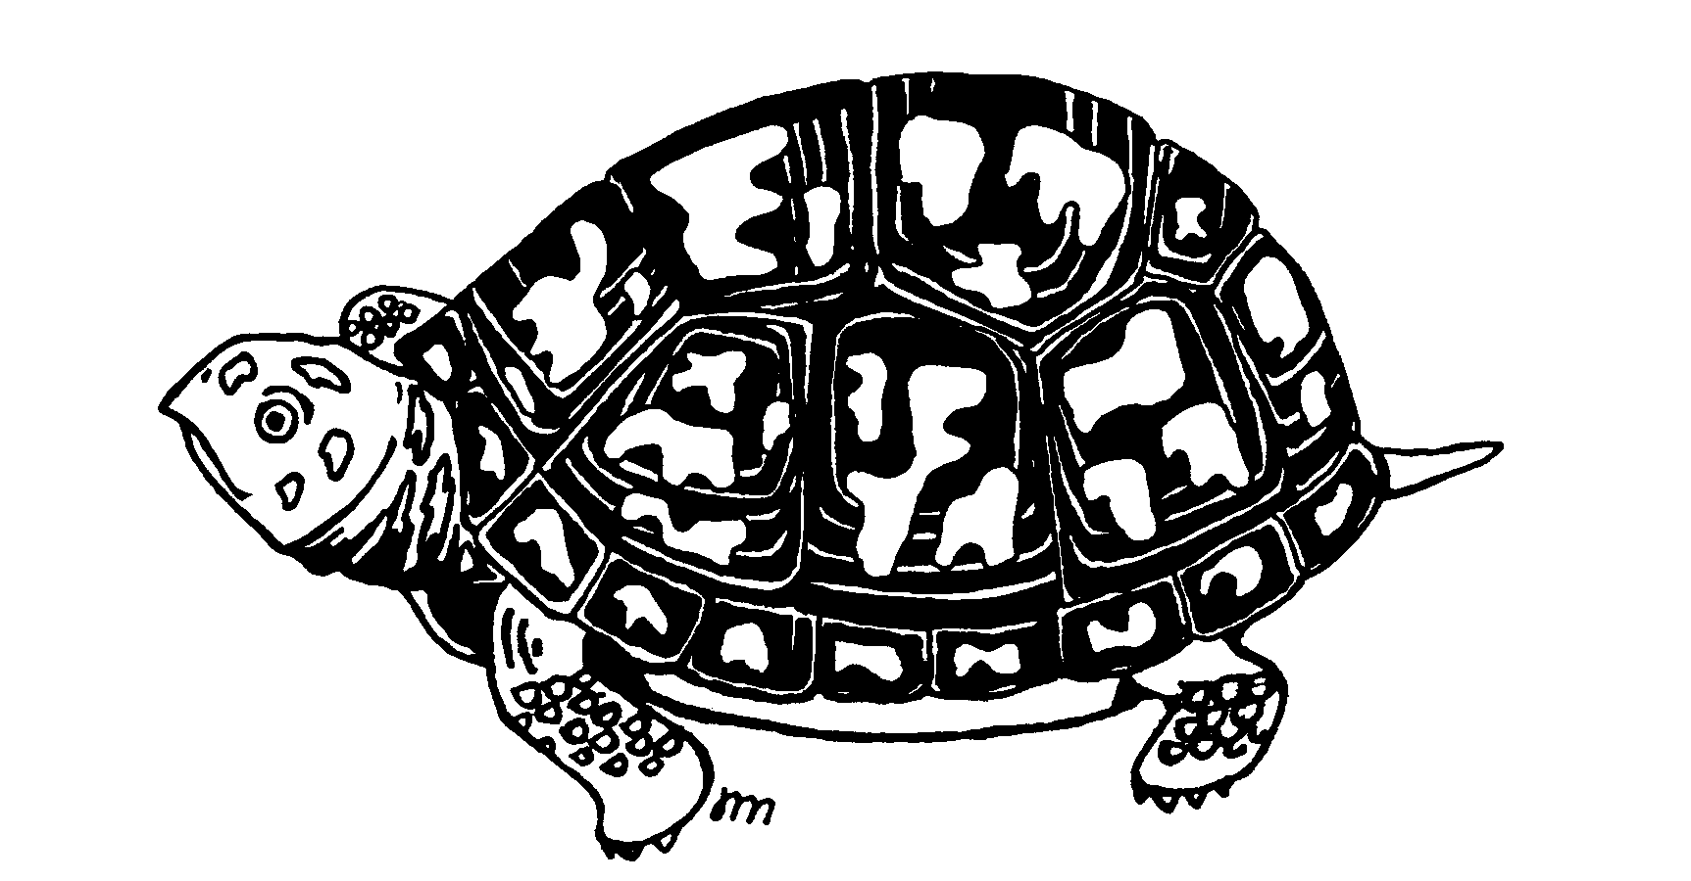
Turtle & Tortoise Society
Of Charleston
Turtle Adoption Application

An Adoption fee of $20.00 is charged for non-members to assure the sincerity of the applicant and to help offset some of the expense associated with the care of the turtle. The fee is reduced to $15.00 for red eared sliders. Included with the adoption fee is a one year membership to the Turtle & Tortoise Society. Adoption fees for Society Members varies from nothing to a small donation worked out before the adoption. A fee may be required to offset the expense of some special cases.

Name:
Street:
City/State/Zip:
Home Phone:
Alt. Phone:
Email Address:

List specific species you are interested in adopting:
How long have you been keeping turtles and tortoises?
What other animals do you own? How do you plan to keep your turtle safe from them?
What type of home do you have? House, apartment, etc.?
Do you rent your home? If so, are you allowed to keep a turtle?
Do you have a yard? If so, is it fenced?
If you have an outdoor enclosure, how is it protected from predators?
Have you ever adopted a turtle from another rescue? If so, who and when?
Describe, in detail, your turtle setup: Include details about lighting, heating, environment, substrate, caging. etc.
Describe diet, care, and maintenance:
If your adopted turtle becomes sick, are you willing to take it to a vet? If so, type the name and address of the herp vet you plan to use.
What will you do if your adopted turtle does not get along with your existing turtles?
Have you ever released a captive turtle into the wild?
If you have children, describe how their interactions will be handled with the turtle.
Lastly, describe why you want to adopt a turtle/tortoise.

By submitting this form you agree that:
1. All the information provided above is true and accurate.
2. If you become an adopter, you will keep the turtle or tortoise for the remainder of its life.
3. You will contact TTSC if, for whatever reason, you can no longer keep or take care of the animal.
4. You will provide the turtle/tortoise with proper housing, maintenance, food, and care.
5. You will take it to the vet if it is sick.
6. You will NEVER release the turtle/tortoise into the wild.
7. You are responsible for knowing your state laws regarding turtle ownership.
8. You are over the age of 18 or are able to provide parental permission when requested.

